1. SELECT \* FROM CD.FACILITIES;

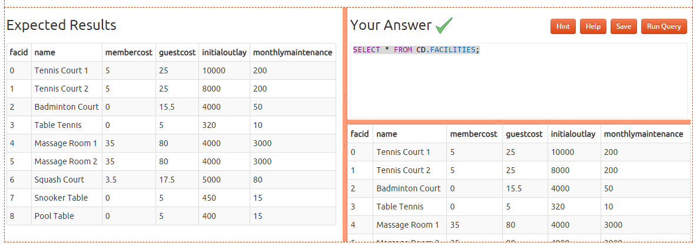

1. select name,membercost from cd.facilities;

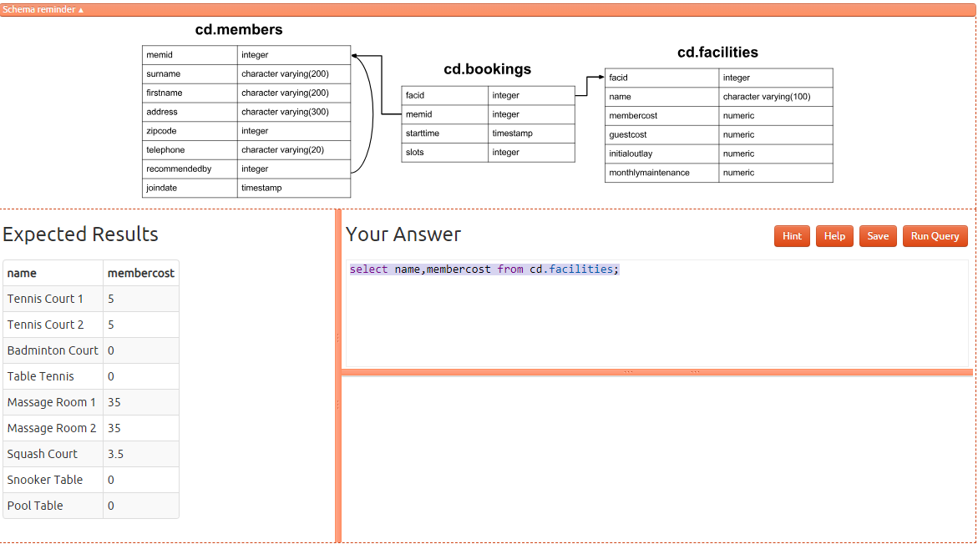

1. select \* from cd.facilities where membercost>0 ; 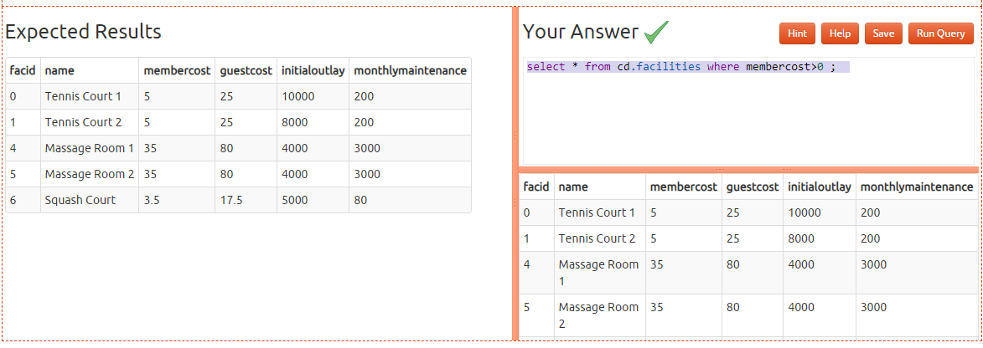
2. select facid, name, membercost, monthlymaintenance

from cd.facilities

where

membercost > 0 and

(membercost < monthlymaintenance/50.0); 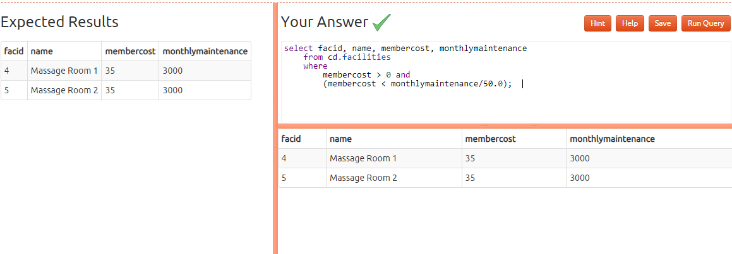

1. select \* from cd.facilities where name like '%Tennis%';

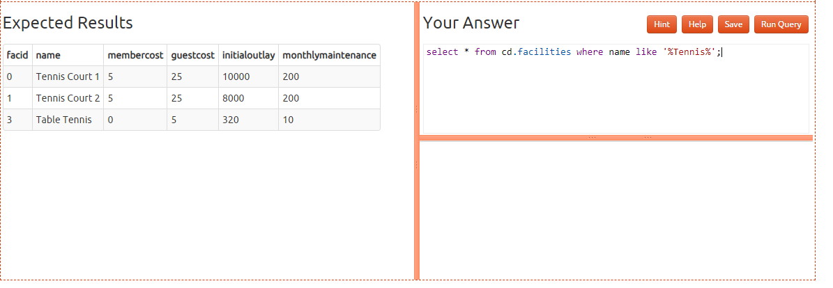

1. select \* from cd.facilities where facid in (1,5);

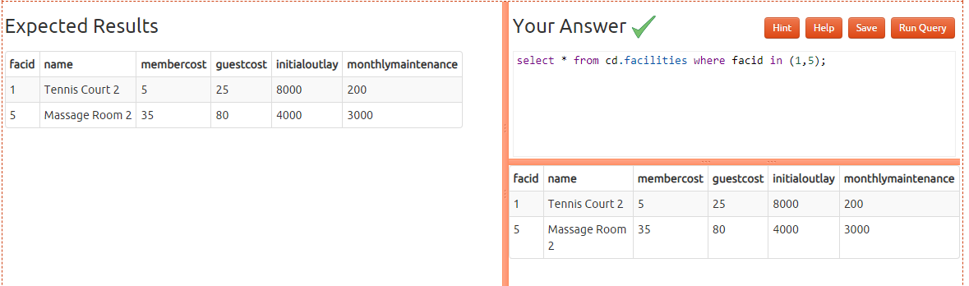

7)) select name,

case when (monthlymaintenance > 100) then

'expensive'

else

'cheap'

end

as cost from cd.facilities; 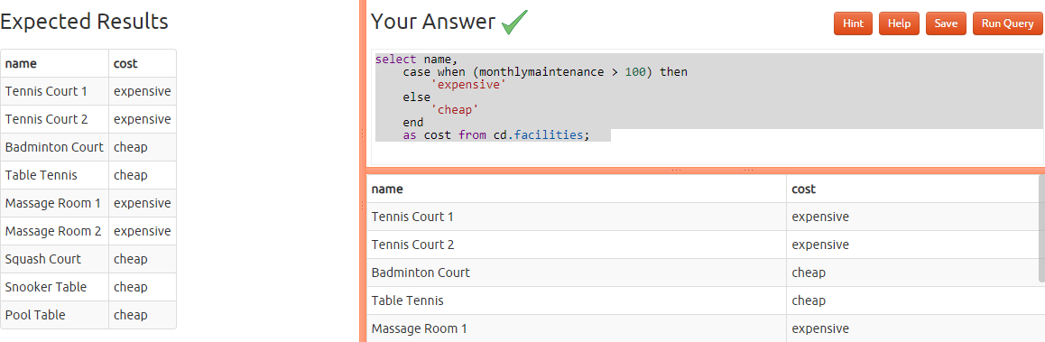

1. SELECT memid,surname,firstname,joindate from cd.members where joindate > '2012-09-01 00:00:00';

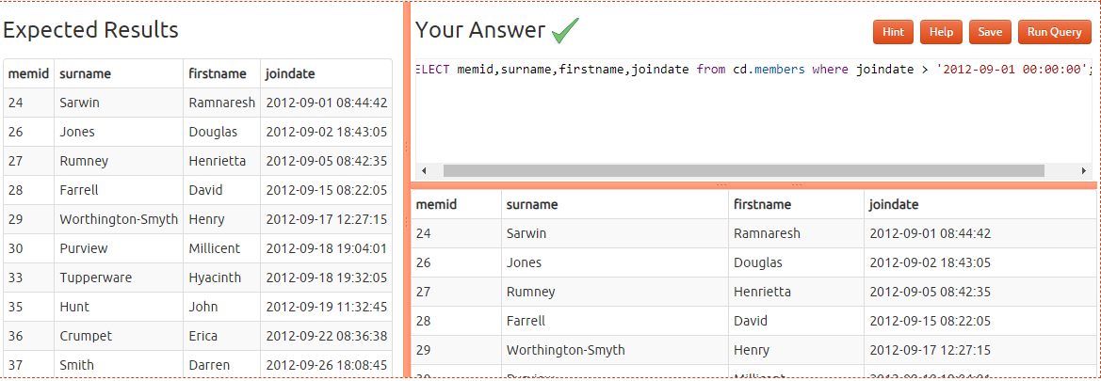

1. select distinct surname from cd.members order by surname limit 10 ;

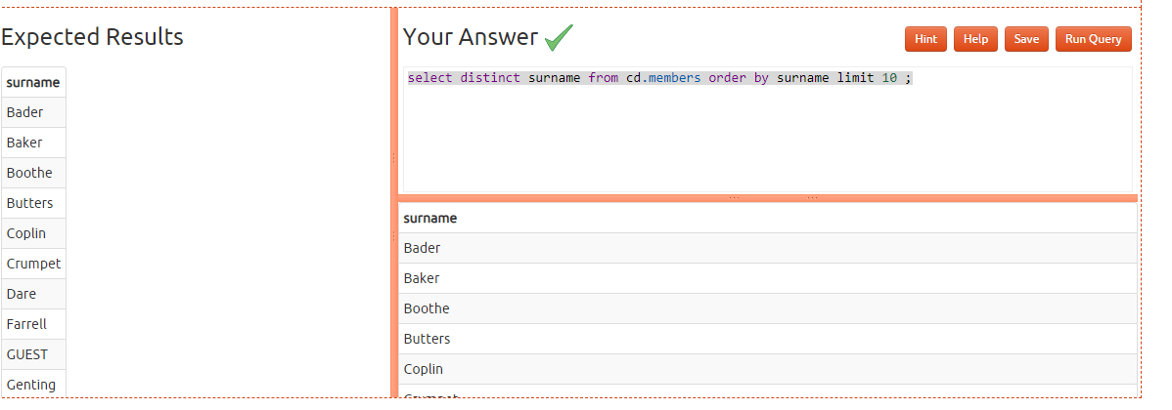

1. select m.surname from cd.members m

union

select f.name from cd.facilities f;

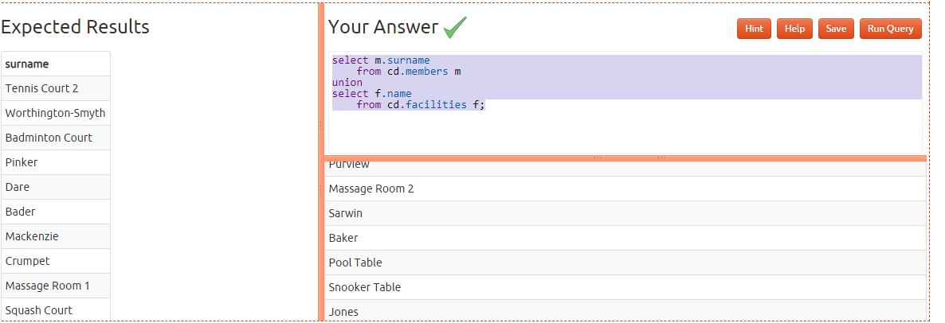

11) select joindate as latest from cd.members order by joindate desc limit 1;

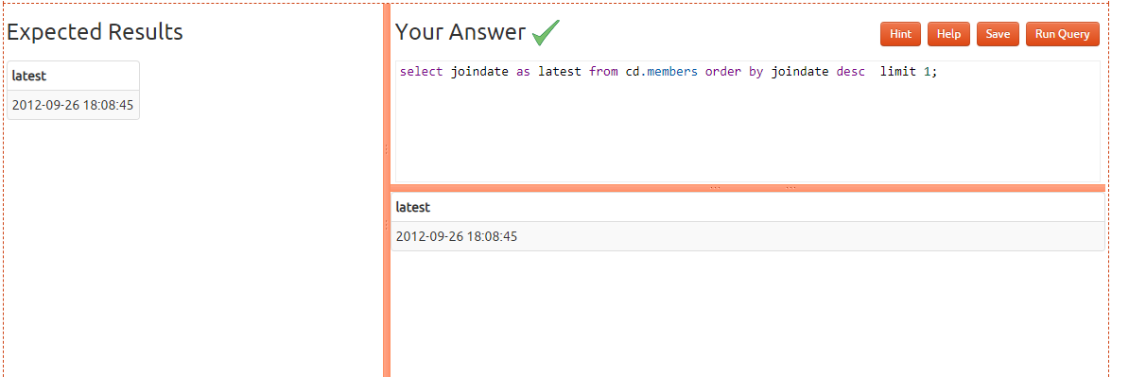

12) SELECT firstname, surname,joindate FROM cd.members WHERE joindate = (SELECT joindate FROM cd.members ORDER BY joindate DESC LIMIT 1);

